Township of Hornepayne Approves Advanced Waste-to-Resource Project to Proceed

Project led by Keystone Platform Inc., with H&G Control as key partner and initial project sponsor, aims to support landfill diversion, energy recovery and Northern Ontario economic development
HORNEPAYNE, Ont. — [July 23rd, 2026] — The Council of the Township of Hornepayne has approved an advanced waste-to-resource project to proceed to the next stage of development, marking an important step toward a new regional approach to waste diversion, resource recovery and clean-energy production in Northern Ontario.
“Viewing household waste as a resource is an important step toward reducing our reliance on landfills. Initial engineering and processing estimates suggest that household waste can be converted into useful products, leaving less than 5% of current landfill-bound waste as residual material. As a consumer society, we must change how we think about waste. Household waste is not simply garbage—it is a resource that can be transformed, allowing us to recover value, recapture energy, and support a more sustainable full-cycle approach: an extraordinary step in the right direction - Waste to Resource.” Cheryl Fort, Mayor of Hornepayne.
The proposed facility is designed to process mixed municipal waste and recover value from materials that would otherwise be sent to landfill. Based on current project planning, the facility is targeting diversion rates in the high-90-per-cent range. The core process is proprietary and protected under a patent held by MS Montan Services, Germany. The same technology can also be used to revitalize landfills for alternative development use.
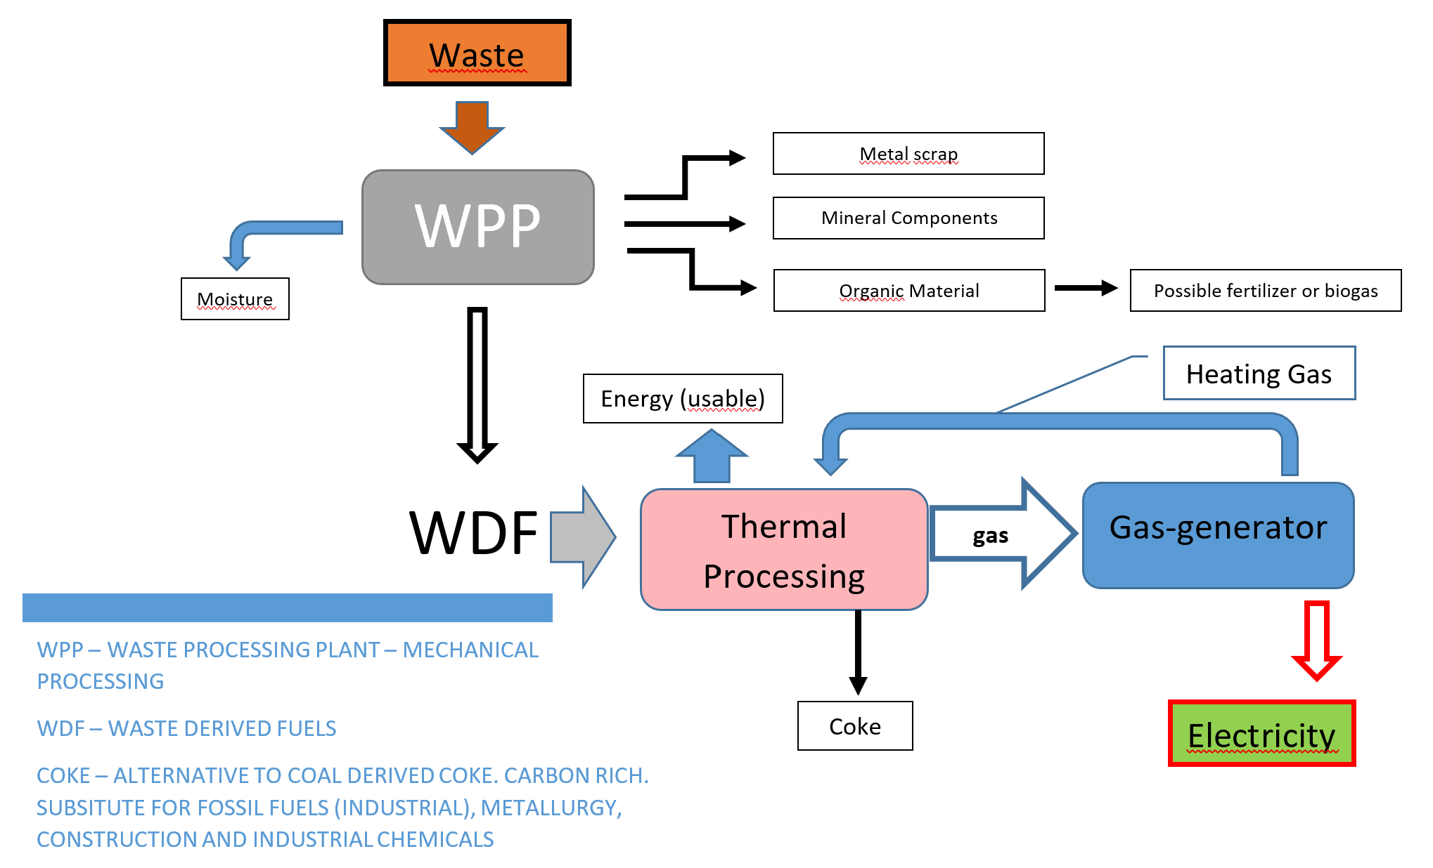
“This is an important milestone for Hornepayne and for the broader effort to find practical, solutions to minimize landfill disposal” said Zulfiqar Mooraj, President and CEO of Keystone Platform Inc. and H&G Control. “We highly appreciate the leadership shown by Mayor Cheryl Fort and Council in considering this innovative project to address Ontario’s waste problem. Consider what we Ontarians send to landfills every year could generate electricity for a city of over 1 million residents besides providing other useful resources.”
The project will now move through the next stages of development, including discussions with stakeholders, securing feedstock, commercial structuring, financing, detailed engineering, environmental and regulatory review.
Construction and operating timelines will be confirmed following completion of these steps and receipt of all required approvals.

Contact:
Zulfiqar Mooraj
President
Keystone Platform Inc. / H&G Control
info@handgcontrol.com

